

|  |  |  |  |
| --- | --- | --- | --- |
| Course Code | : | AIT102 | |
| Course Name | : | Python and tensorflow program | |
| Lecturer | : | Zhang Yingqian | |
| Academic Session | : | 202504 | |
| Assessment Title | : | Group Project | |
| Submission Due Date | : | 27 Jun 2025 | |
| Group Number |  | 10 | |
| Project Title |  | Chess game | |
| Prepared by |  |  | |
| : | Student ID | Student Name |
|  | AIT2209069 | Duan Shujie |
|  | AIT2504281 | Keven Lee Zhang Yan |
|  | AIT2504516 | Siam Nur Ahmed |
|  | IBU2402211 | Liang Fang Wang |
|  | AIT2502092 | Tan Tai Ren |
|  |  |  |
| Date Received | : |  | |
|  |  |  | |
| Feedback from Lecturer:  Mark: | | | |

**Own Work Declaration**

I/We acknowledge that my/our work will be examined for plagiarism or any other form of academic misconduct, and that the digital copy of the work may be retained for future comparisons.

I/We confirm that all sources cited in this work have been correctly acknowledged and that I/we fully understand the serious consequences of any intentional or unintentional academic misconduct.

In addition, I/we affirm that this submission does not contain any materials generated by AI tools, including direct copying and pasting of text or paraphrasing. This work is my/our original creation, and it has not been based on any work of other students (past or present), nor has it been previously submitted to any other course or institution.

Signature:

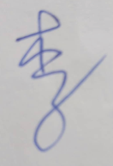卡通人物

AI 生成的内容可能不正确。图形用户界面

AI 生成的内容可能不正确。 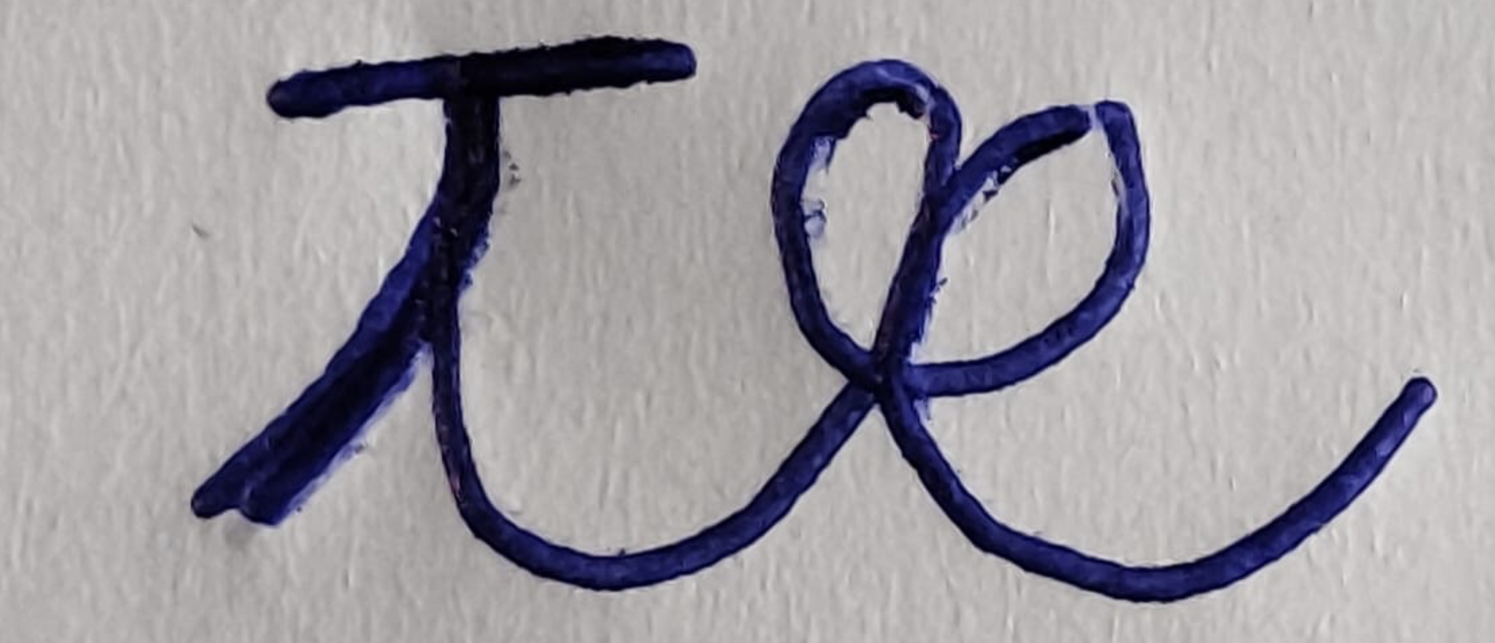卡通人物

AI 生成的内容可能不正确。

Date:2025/06/27

**APPENDIX 1**

**Marking Rubrics**

|  |  |  |  |  |  |  |  |
| --- | --- | --- | --- | --- | --- | --- | --- |
| **Component Title** | **Group Project (Code)** | | | | **Percentage (%)** | **30** | |
| **Criteria** | **Score and Descriptors** | | | | | **Weight (%)** | **Marks** |
| **Excellent**  **(10)** | **Good**  **(8-9)** | **Average**  **(6-7)** | **Need Improvement**  **(3-5)** | **Poor**  **(1-2)** |
| **Program**  **Functionality** | The program meets the listed specifications and does what it was designed to do with no issues. | The program meets the listed specification s and works most of the time with some issues. | The program meets the listed main specifications and works most of the time with some issues. | The program does not meet the listed specifications or works intermittently. | The program does not work at all | **10** |  |
| **Level of**  **Effort** | The program is very challenging and ambitious and TensorFlow programming is used. | The program is moderately ambitious and takes some effort. | The program is a sense of ambitious and takes some effort. | The program is simple but is well designed. | The program is too simple and is poorly designed | **10** |  |
| **Criteria** | **Excellent**  **(5)** | **Good**  **(4)** | **Average**  **(3)** | **Need Improvement**  **(2)** | **Poor**  **(1)** |  |  |
| **Code Quality** | The code is well organized with perfect style (e.g., the code is non-repetitive, methods and variables are named appropriately, control and logical structures are used appropriately, etc.). | The code is well organized and has minor style issue. | The code is completely organized and has minor style issue. | The code is poorly organized or has major style issue | The code is a total mess. | **5** |  |
| **Team work** | Show clear evidence to assume alternate roles as a group  leader and a group member demonstrated in  practice | Able to demonstrate in practice the ability to assume alternate roles as a group leader and a group member to achieve the same goal | Able to demonstrate  in practice the  ability to assume  alternate roles as a group leader and members  with some effect(s) and require minor  improvements. | Attempt to  demonstrate in practice the ability to  alternate roles as a group leader and group members but with limited  effect and require  improvements | No clear  evidence of ability to assume alternate roles as a group leader and group members  demonstrated in practice | **5** |  |
| **TOTAL** | | | | | | **30** |  |

Note to students: Please include the marking rubric when submitting your coursework

|  |  |  |  |  |  |  |  |
| --- | --- | --- | --- | --- | --- | --- | --- |
| **Component Title** | **Group Project (presentation)** | | | | **Percentage (%)** | **20** | |
| **Criteria** | **Score and Descriptors** | | | | | **Weight (%)** | **Marks** |
| **Excellent**  **(5)** | **Good**  **(4)** | **Average**  **(3)** | **Need Improvement**  **(2)** | **Poor**  **(1)** |
| **Presentation Content** | The presentation is  well organized with  clear structure, good  logic and solid content | The presentation is completed with required content. | The presentation is completed with most required content. | The presentation is not well organized. | very poor presentation or no presentation is submitted. | **5** |  |
| **Presentation Design** | The design looks very professional, with clear, high-quality images, neat alignment, and good use of colors. Everything matches well, making it easy and enjoyable to follow | The design is nice, with helpful visuals and mostly matching colors and fonts. It’s easy to look at, though small improvements could make it even better. | The design is plain, with some useful visuals, but the colors and fonts don’t always match. It’s organized but not very eye-catching. | The design is cluttered and uses outdated visuals. The colors and fonts are inconsistent, making it look busy and harder to follow. | The design is messy, with low-quality visuals and random colors and fonts. It’s hard to follow, and nothing feels organized or connected. | **5** |  |
| **Communication Skills** | Start, maintain and  end a presentation  naturally. Use appropriate eye  contact and body  language. Take turn to talk with respect. | Start, maintain  and end a  presentation in a friendly  manner.  Maintain good eye contact.  Take turn to  talk with  respect | Take the initiative to start a presentation.  Appropriate  eye contact. Take turn to talk | Take part in  presentation when initiated  by others.  Limited eye  Contact. Interfere  presentation | . Less interest to participate in presentation  No eye contacts.  Always disrupt  presentation | **5** |  |
| **Overall Impression** | The presenter impressively shows professionalism, confidence, and engagement, demonstrating exceptional knowledge and expertise in the subject | The presenter exudes professionalism, confidence, and competence, shows a good level of knowledge and expertise in the subject | The presenter displays a basic level of professionalism with less confidence, an average level of knowledge in the subject | The presenter's lacking professionalism, confidence, and engagement, along with limited knowledge in the subject, | The presenter's unprofessional behavior, lack of confidence, disengagement, and significant lack of knowledge and expertise in the subject. | **5** |  |
| **TOTAL** | | | | | | **20** |  |

Note to students: Please include the marking rubric when submitting your coursework